VICE-CHANCELLOR OF RAJASTHAN UNIVERSITY OF HEALTH SCIENCES (RUHS)

Name :-Dr. Sudhir Bhandari
Vice-Chancellor, Rajasthan University Designation :-of Health Sciences, Jaipur
MBBS (TRIPLE GOLD MEDIALIST) Qualification :-MD, FRCP (LONDON), FACP, FACE, DNB,
MNAMS, FICP, AFICA (USA), FISC,
FRSSDI FELLOW F DIABETES INDIA (FDI)
O

Contact No :-
Office : 0141-27102324, 2710434

Mobile Mo.: +91-98290-78844

Website :-www.ruhsraj.org

drs_bhandari@yahoo.com
E-mail :-
dr.bhandaricr@gmail.com

Experience :-More than 27 Years Academic & Administrative work experience

REGISTRAR OF RAJASTHAN UNIVERSITY OF HEALTH SCIENCES (RUHS)

Name | :- | SHRI HARPHOOL PANKAJ, RAS | 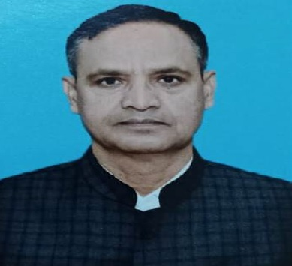
Designation | :- | Registrar, Rajasthan University of Health Sciences, Jaipur
Date of Birth | :- | 15.07.1968
Qualification | :- | NET, M.A., B.A. Hon’s Geography
Contact No | :- | Office : 0141-2795548
Website | :- | www.ruhsraj.org
E-mail | :- | registrar@ruhsraj.org
Experience | :- | 28 Years Admistrative work experience in the various departments of State Government.

